STRATEGY FOR THE FAMILY CARER MENTAL HEALTH WORKFORCE
IN VICTORIA

Authorised by the Lived Experience Workforce Strategies Stewardship Group. Published by the Centre for Mental Health Learning.
Suggested citation:
Lived Experience Workforce Strategies Stewardship Group (2019). Strategy for the Family Carer Mental Health Workforce in Victoria. Centre for Mental Health Learning Victoria (CMHL): Melbourne
© Centre for Mental Health Learning, June 2019. Available at https://cmhl.org.au

Strategy for the Family Carer Mental Health Workforce in Victoria

Contents

Definitions 3
Introduction 4
Purpose 4
Stewardship of Victoria’s lived
experience workforce strategies 5
Strategy for the family carer mental
health workforce in Victoria 6
Themes and objectives 6
Action Plan 8
APPENDIX 1
Victoria’s family carer workforce 14
APPENDIX 2
The Carer Workforce Development Group 15
APPENDIX 3
Process for development of the Strategy 16
APPENDIX 4
Organisations, resources and initiatives
that support the family carer workforce 17
References 20

Definitions

Carer
A carer is someone who is actively supporting, assisting or providing unpaid care to a consumer. A carer may or may not live with the consumer. A carer may be a family member, friend or other person, including someone under the age of 18 years, who has a significant role in the life of the consumer. (Department of Health and Human Services, 2018, p. 5)

Family
Family is culturally grounded; for example, Australian Aboriginal nations each have rich, complex and nuanced kinship and family structures which prescribe relationships and responsibilities people have to each other and the land.
Family includes the consumer and those with a significant personal relationship with the consumer. This includes biological relatives and non-biological relatives, intimate partners, ex-partners, people in co-habitation, friends, those with kinship responsibilities, and others who play a significant role in the consumer’s life. Some family members may identify themselves as a ‘carer’ in a consumer’s
life, others will identify more so with the characteristic of their relationship (for example; parent, child, partner, sibling). (Department of Health and Human Services, 2018, p. 5).
For people who have experienced familial rejection, neglect or abuse, recognition of their ‘family of choice’ is especially important.

Carer worker
The Australia Institute of Health and Welfare describes mental health carer workers as:
Persons employed (or engaged via contract) on a part-time or full-time paid basis, where the person is specifically employed for the expertise developed from their experience as a mental health carer.
Mental health carer workers include the job titles of, but not limited to, carer consultants, peer support workers, carer support workers, carer representatives and carer advocates. (Australian Institute of Health and Welfare, 2018)

Family carer worker, family carer workforce
Family carer workforce is a collective term for family carer workers in a range of roles. Family carer workers provide support and connection for people who are in a consumer’s family, some of whom may identify as a carer. Family carer workers may do this directly through providing peer support, or indirectly through leadership, advocacy, education, and research. Lived experience as a carer is an essential part of the selection criteria, with other skills and knowledge required depending on the role.
The authors of this document have chosen the terms ‘family carer worker’ and ‘family carer workforce’ as it is respectful of those who prefer to identify by their relationship rather than as a carer.
The family carer workforce referred to in this document are in paid roles within Victorian publicly funded mental health services.
However, the activity and supports detailed in this document could be applicable for any family carer role (for example those in other sectors, volunteer roles, academic positions and others).
More information about Victoria’s family carer workforce can be found in Appendix 1 - Victoria’s family carer workforce.

Introduction

The Victorian family carer workforce reflects the efforts of many families, friends, consumers, service providers, and policy leaders who paved the way for the employment of the first family carer workers in Victoria in 1999. Since this time, Victorian Government initiatives such as the Expanding Post Discharge Support initiative have stimulated expansion of the workforce, both in number and scope. This document provides a vision for the workforce as it moves forward.
Work on this document has been led by the Carer Workforce Development Group, in partnership with the Department of Health and Human Services, as part of a broader project of work leading the consumer and carer workforce initiatives in Victoria. Further information about the Carer Workforce Development Group, including members,
can be found in Appendix 2 - The Carer Workforce Development Group.
In collaboration with other family carer workers, the Carer Workforce Development Group has developed a vision for the family carer workforce. Practical steps to make the vision a reality have been mapped out and are contained within this document. This information, together with data from a lived experience workforce census and a training needs analysis, will support planning for family carer workforce training and development over the coming years.

Purpose
The intention is for the Strategy for the family carer workforce in Victoria (the Strategy) to support resourcing and planning for the family carer workforce training and development over the coming years. It is envisaged that initiatives from the strategy will be family carer-led, in collaboration with other partners, with aspects of the Strategy requiring government investment and other organisational support to implement.
The Strategy will assist policy developers, funders, family carer workers and their employers, and will be useful for organisations planning to employ family carer workers. It describes the required activity needed to adequately support and develop the workforce and should be carried out in partnership and with leadership from family carer workers.

Stewardship of Victoria’s lived experience workforce strategies

Victoria’s lived experience workforce strategies comprise:
- Strategy for the consumer mental health workforce in Victoria
- Strategy for the family carer mental health workforce in Victoria
- Strategy for the alcohol and other drug (AOD) peer workforce in Victoria

Stewardship of these strategies is held collectively by (listed in alphabetical order):
- The Bouverie Centre, La Trobe University
https://www.bouverie.org.au/
- Carer Lived Experience Workforce Network (CLEW) https://www.tandemcarers.org.au/carer-lived-experience-network.php
- Centre for Mental Health Learning (CMHL)
https://cmhl.org.au/
- Centre for Psychiatric Nursing, Melbourne University
https://healthsciences.unimelb.edu.au/departments/nursing/about-us/centre-for-psychiatric-nursing
- Department of Health and Human Services
https://www2.health.vic.gov.au/mental-health
- Mental Health Victoria
https://www.mhvic.org.au/
- Self Help Addiction Resource Centre (SHARC) http://www.sharc.org.au/
- Tandem https://www.tandemcarers.org.au/
- Victorian Dual Diagnosis Initiative Leadership Group (VDDI LG)
http://www.dualdiagnosis.org.au
- Victorian Mental Illness Awareness Council (VMIAC) https://www.vmiac.org.au/

The Lived Experience Workforce Strategies Stewardship Group will:
- Advocate for, promote and support lived experience workforces.
- Identify and drive opportunities to progress toward the vision of the strategies.
- Identify, create or advocate for funding opportunities to undertake actions of the strategies.
- Provide leadership and oversight for implementation of, and progress towards, strategy priorities.
Many consumers and carers have experiences of seeking support from both mental health and alcohol and other drugs (AOD) services. Lived experience workers may have experienced both mental health and substance use issues, or supported a family member or friend who has experiences of both.
The strategies and stewardship group create a unique opportunity for a more inter-sectorial and collaborative approach to supporting
mental health and/or AOD consumers and their family/carers, regardless of which sector they interact with.
The strategies stewardship group includes representation from lived experience workforces, organisations and networks involved in research, mental health, AOD, and dual diagnosis. We come together in order to strengthen collaborative network alliances for the lived experience workforces and learn with and from each other.
We encourage organisations to adopt and support this action plan to expand and support the family carer workforce. Collective effort
is required to achieve the objectives in this Strategy and activity is already happening within services and beyond. To ensure that activity is recognised and can be shared and promoted across the family carer workforce, please advise of relevant activity by contacting:
Family Carer Workforce Development Coordinator, CMHL Vic contact@cmhl.org.au

Strategy for the family carer mental health workforce in Victoria

Themes and objectives
The Strategy activities are organised into four themes:
  - Defining the discipline and roles;
  - Promoting family carer work;
  - Supporting the workforce; and
  - Growing the workforce
Figure 1 shows that defining the discipline is central as all other categories are dependent on a clear understanding of the work. A clear understanding of the scope of the work, together with promoting and supporting, provide a strong foundation from which to grow the workforce.

FIGURE 1: Family carer workforce strategy themes
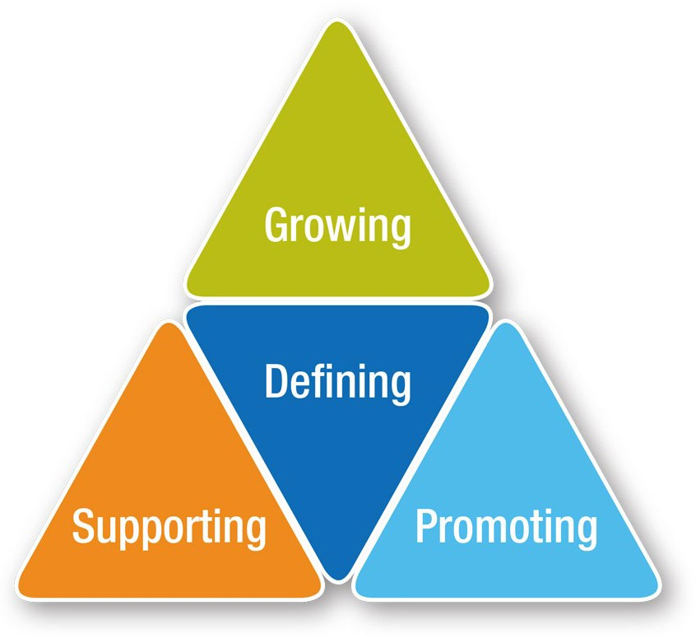

The various consultation activities which resulted in identification of the four themes are briefly summarised in Appendix 3 – Process for development of the Strategy.
Each of the themes has a number of objectives sitting within that theme, however in reality the objectives are interrelated and overlap.

Defining
  - Family carer work is recognised as a discipline, with several specialisations within the discipline (e.g. peer support worker, consultant, advocate etc.).
  - Principles of family carer work are identified and adopted.
  - Roles, responsibilities and expectations are clearly defined and consistent across organisations, while taking into account local needs.
  - Family carer work is based on a clear understanding of the needs of families and family carers
– grounded in research and real-life experiences of families and carers.

Promoting
    - Family carer work has status, is valued, and seen as an essential component of mental health, and alcohol and other drugs (AOD) services.
    - Organisations understand, support and value family carer work.
    - Family carer and consumer workers value, respect and promote each workforces’ unique contributions and partner together to promote lived experience work.

Supporting
    - Family carer workers clearly understand their roles and responsibilities, and have the knowledge, experience and skills to be effective in their work.
    - Family carer workers have tools and resources to support their work.
    - Family carer workers in direct support roles have knowledge and skills in navigating and locating supports available for families and carers.
    - Supervision and reflective practice processes are available, encouraged, supported and facilitated.
    - Family carer workforce has access to both discipline-specific supervision and line management supervision.
    - Family carer workforce has access to peer networks and opportunities for networking are valued, supported and promoted.
    - Managers and organisations provide flexible workplace conditions, in accordance with legislation and policy, to support family carer workers.

Growing
    - Family carer workers are employed in leadership roles, including identified family carer roles in state government.
    - Family carer workers have pay parity with like positions, skills and responsibilities.
    - Family carer workers have job security and opportunities for full-time work and career progression.
    - There are an appropriate number of positions to respond to the needs of families and carers.
    - Mentoring, education, support and career pathways exist for those interested in entering the paid family carer workforce.
    - Family carer workers are supported by a professional body or centre of excellence.
    - Family carer workforce reflects the diversity of the communities they are supporting.
Actions to achieve these objectives for the family carer workforce were identified and prioritised in consultation with the workforce. These are described in the following section.

Action Plan

1.4.2 Create a knowledge bank or library of evidence based on family carer perspectives.

Medium

A guide to the proposed timeframes:
  - Immediate – complete within 12 months
  - Medium – complete within 3 years
  - Longer term – complete in 3 – 5 years

1 DEFINING – the discipline and roles

OBJECTIVES

ACTIONS
PROPOSED TIMEFRAME
1.1 Family carer work is recognised as a discipline, with several specialisations within the discipline (e.g. peer support worker, consultant, advocate etc.).

    - Clarify principles and practice of family carer work and specialisations:
      - Undertake literature review on family carer work
      - Research current practices in Victoria, Australia, internationally

Immediate

1.2 Principles of family carer work are identified and adopted.

1.2.1 Develop principles, tasks and ethics related to family carer work and specialisations.

Immediate

1.3 Roles, responsibilities and expectations are clearly defined and consistent across organisations, while taking into account local needs.

1.3.1 Develop template position descriptions listing core principles, practices, responsibilities, knowledge, skills and experience required for the position

Medium

1.4 Family carer work is based on a clear understanding of the needs of families and carers
– grounded in research and real-life experiences of families and carers.

1.4.1 Gather and translate evidence into practice through training and development resources.

Medium

2.1.2 Communicate key common policies and standards that family carer workforce contribute to (i.e. to support accreditation).

2.1.3 Develop videos and other media sources to promote the benefits of family carer workforce.

Medium

Immediate

Medium
2.2.2 Co-design training about family carer work for managers, and others working alongside family carer workers.

2 PROMOTING THE WORK

OBJECTIVES

ACTIONS
PROPOSED TIMEFRAME

2.1 Family carer work has status, is valued, and is seen as
an essential component of mental health and alcohol and other drugs (AOD) services.

2.1.1 Develop and implement a communication strategy to disseminate information about family carer work, including the benefits of family carer work.

Medium

2.2 Organisations understand, support and value family carer work.

Immediate

2.3 Family carer and consumer workers value, respect and promote each workforces’ unique contributions and partner together to promote lived experience work

Immediate

2.2.1 Undertake a survey to establish a baseline of services knowledge about family carer work.

2.3.1 Work with the Consumer Workforce Development Group to build relationships and mutual understanding and explore work that can be progressed together to promote lived experience work.

3.1.2 Conduct a training needs analysis to understand education and training needs of family carer workforce (workforce survey, managers’ survey, focus groups, consultation) including knowledge, skills and experience.
3.1.4 Develop training for family carer workforce to guide, support and improve practice and address knowledge and skill gaps.
3.1.3 Secure ongoing commitment to fund training and workforce development activities for family carer workforce. Ensure this funding is sufficient to ensure training is accessible (e.g. rural workers).
3.1.5 Produce a calendar of training and education events for different specialisations and from entry level through to supervision and leadership roles.

Immediate

Immediate

Immediate

Medium

Longer term

Medium
3.2.2 Develop resources for family carer workers to share about family carer experiences which can be contextualised
to different audiences e.g. university students, new graduates, executive managers etc.
3.2.3 Advocate for family carer workers to have sufficient resourcing to conduct their work safely and effectively, and taking into account local need (e.g. population demographics, travel required).
3 SUPPORTING THE WORKFORCE

OBJECTIVES
ACTIONS
PROPOSED TIMEFRAME

3.1 Family carer workers clearly understand their roles and responsibilities, and have the knowledge, experience and skills to be effective in their work.

3.1.1 Develop and implement a strategy to communicate the principles, values, knowledge, skills and experience of family carer work and facilitate the adoption of these.

Medium

3.2 Family carer workers have tools and resources to support their work.

3.2.1 Co-design or identify relevant practice resources or toolkits and disseminate these. This includes resources to support family carer workforce to provide information, deliver education and training for families and carers.

Medium

Longer term

Immediate

Medium

Medium

Immediate
3.4.2 Identify, support and develop current and potential supervisors.
3.5.2 Develop training about how to use the online networking spaces to ensure these are accessible.
3.4.3 Create pathways for organisations and individuals to access discipline specific supervision.
3.5.3 Identify, support and promote local networks, hubs or communities of practice (including for different specialties,
i.e. educators and people in leadership roles).
3.5.4 Advocate for additional funding for rural family carer workers to cover travel expenses to attend face to face training and networking events.

3 SUPPORTING THE WORKFORCE
(continued)

OBJECTIVES
ACTIONS
PROPOSED TIMEFRAME

3.3 Family carer workers in direct support roles have knowledge and skills in navigating and locating supports available for families and carers.

3.3.1 Establish effective ways of keeping the lived experience workforce up to date about family carer supports and services, including training, support and information
to develop skills in service mapping, development of partnerships and referral pathways that will assist families and carers in their local area.

Immediate

3.4 Supervision and reflective practice processes are available, encouraged, supported and facilitated. Family carer workforce has access to both discipline- specific supervision and line management supervision.
3.4.1 Identify or develop relevant supervision and reflective practice models, guidelines, resources and training

Immediate

3.5 Family carer workforce has access to peer networks and opportunities for networking are valued, supported and promoted.
3.5.1 Develop and maintain online networking spaces (e.g. Basecamp) for family carer workforce to connect with others, get support, ask questions, and share information and resources.

Immediate

3.6 Managers and organisations provide flexible workplace conditions, in accordance with legislation and policy, to support family carer workers.

3.6.1 Develop and deliver training and resources for managers, and human resources staff.

Medium

4.2.2 Build relationships with unions and peak bodies (Tandem, Mental Health Vic) to support them to better understand and advocate for family carer workforce.
4.2.3 Advocate for a new classification in the EBA – lived experience educators

Immediate

Medium

Immediate
4.5.2 Identify processes for recruitment, orientation and mentoring of new family carer workers.
4 GROWING THE WORKFORCE

OBJECTIVES
ACTIONS
PROPOSED TIMEFRAME
4.1 Family carer workers are employed in leadership roles, including identified family carer roles in state government.

4.1.1 Co-design a family carer worker leadership program, with mentoring and peer support networks.

Longer term

4.2 Family carer workers have pay parity with like positions, skills and responsibilities.

4.2.1 Map EBA and awards.

Immediate

4.3.1 Career pathways are mapped and promoted, and training identified to support each pathway.

Medium

4.3 Family carer workers have job security and opportunities for full time work and career progression.

4.4 There are an appropriate number of positions to respond to the needs of families and carers.
4.4.2 Recommend a ratio for paid family carer roles.
Medium

4.4.1 Understand and map current workforce and positions. Immediate

4.5 Mentoring, education, support and career pathways exist for those interested in entering the paid family carer workforce.
4.5.1 Develop a fact sheet on reasonable adjustments and flexible workplaces for families and carers.

Immediate

Medium

4.7.2 Identify and implement strategies for partnering with community groups and agencies to increase diversity of workforce.

4 GROWING THE WORKFORCE
(continued)

OBJECTIVES
ACTIONS
PROPOSED TIMEFRAME

4.6 Family carer workers are supported by a professional body or centre of excellence.

4.6.1 Support development of a professional body or centre of excellence for the family carer workforce.

Longer term

4.7 Family carer workforce reflects the diversity of the communities they are supporting.

Immediate

4.7.1 Ensure training, support and resources are accessible and culturally safe

Victoria’s family carer workforce

A survey undertaken in 2017, identified 341 lived experience workforce positions in Victoria, totalling 187 EFT. Just under one-third of Victoria’s mental health lived experience workforce are employed in a family carer role (n = 104) with the majority employed in peer support worker roles, closely followed by Carer Consultants (as can be seen in Figure 2). (Department of Health and Human Services, 2018).

FIGURE 2: Family Carer Lived Experience Workforce, Victoria
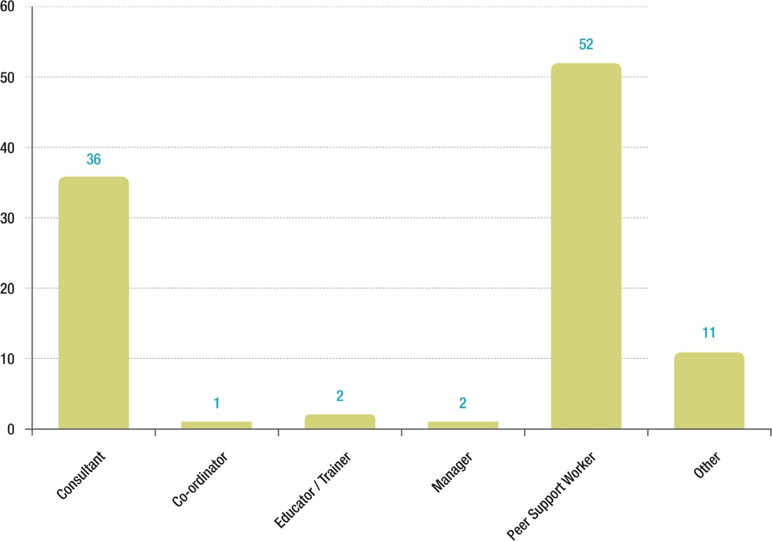

Hours of employment - full time equivalent (FTE)
Another of the challenges facing the workforce is that currently the majority of positions are only part-time. Of the 104 positions identified in the survey:
  - 33 positions are ≤ 0.4 FTE (2 days or less)
  - 15 positions are 0.5 FTE (2 – 3 days per week)
  - 24 positions are 0.6 (3 days per week)
  - 2 positions are 0.7 FTE (3 – 4 days per week)

- 11 positions are 0.8 FTE (4 days per week)
- 10 positions are full-time
- 8 positions are casual
- 1 position the hours of work are unknown
This means that the vast majority of the family carer workforce are employed 3 days or less per week.

Leadership positions
One of the challenges for both the family carer and consumer workforces is the limited career development pathways into leadership positions within mental health services. The survey demonstrated that for the 104 family carer positions, there were three positions that managed other family carer workers as part of their role, and 10 that were providing discipline specific supervision to family carer workers.

The Carer Workforce Development Group

Since 2016 the Carer Workforce Development Group has worked in partnership with the Department of Health and Human Services, Victoria (the department) to provide direction and advice for policy and initiatives that relate to the family carer workforce. Members of the Carer Workforce Development Group are all family carer workers with experience across a range of roles, and two department members.
The Carer Workforce Development Group and a similar Consumer Workforce Development Group have had support from two state-
wide workforce development positions. These positions, located in the sector, have undertaken work together and separately with the respective consumer and family carer workforce groups to advance the lived experience workforce in Victoria.

Membership
  - Cate Bourke, Eastern Health
  - Ian Brooks, Merri Health CarerLinks North (formerly of MIND)
  - Emma Cadogan, Department of Health and Human Services
  - Katrina Clarke, Monash Health, Victorian representative on the National Mental Health Consumer and Carer Forum
  - Lorna Downes, Centre for Mental Health Learning, Victoria (formerly of Centre for Psychiatric Nursing University of Melbourne and St Vincent’s Hospital Melbourne)
  - Rachael Lovelock, Wellways
  - Peter McKenzie, Bouverie Centre
  - David Neef, Eastern Health, EACH
  - Heather Pickard, SHARC
  - Lynne Ruggiero, CLEW (formerly of Forensicare, Star Health and Alfred Health)
  - Amber Scanlon, Department of Health and Human Services
  - Michelle Swann, NorthWestern Mental Health

Mission
The Carer Workforce Development Group provide and foster lived experience discipline leadership to ensure the family carer lived experience workforce is recognised, valued, supported, developed and appropriately resourced.

Principles
The Carer Workforce Development Group:
- are committed to effecting better outcomes and improving the wellbeing of the family carer workforce
- are open to change, doing things differently and taking wise risks
- recognise, respect and build on existing experience, knowledge and evidence
- are solution focussed, clear on purpose, know where we are going and take others with us
- focus on aspirations, potential, possibility and hope
- identify, develop & foster leadership within the family carer workforce and within services to better support family carer workforce
- value and learn from diversity through mutuality and reciprocity
- use collaborative methods to bring together and learn from experience, knowledge and wisdom
- acknowledge and promote relational connectedness (interpersonal and systems)
- learn from and promote learning from family carer lived experience
- challenge inequity and promote rights

Process for development of the Strategy

The Strategy for the Family Carer Mental Health Workforce was created through a collaborative process. Initial planning and strategy workshops were held with the Carer Workforce Development Group on 26 July and 18 August 2017 at 50 Lonsdale Street, Melbourne.
The Strategy incorporates themes from these activities, as well as:
  - Consumer and Carer Workforce Strategy Consultation Paper (2013)
  - Tandem Victorian Mental Health Carer Strategy: Discussion Paper (n.d.)
  - March 2015 Carer Partnership Dialogue – the role of government, family carer peak, directors and managers, clinicians, community sector partners, training providers and the family carer workforce in organisational change
  - May 2015 Family carer Partnership Dialogue – ideas and recommendations for a mental health carer strategy
  - Sept 2015 carer Partnership Dialogue – NDIS Roundtable discussion
  - 2016 Carer Consultants Network Victoria (CCNV) Carer Peer Workforce Forum, Carer Peer Workforce Dialogue facilitated by Peter McKenzie
  - Consultation held with the Family Carer Lived Experience Workforce (CLEW) on 14 September 2017, from which key themes emerged which provided structure for the plan
  - The Strategy for the Family Carer Mental Health Workforce consultation paper distributed widely in March 2018

Organisations, resources and initiatives that support the family carer workforce

This section outlines existing structures (such as organisations and networks), resources and initiatives that will support achievement of the actions in this Strategy. It is recognised that these structures and initiatives are growing and evolving, and the current content reflects the situation as at January 2019.

Organisations
The Bouverie Centre, La Trobe University – is Victoria’s family institute and research centre and offer learning and development and research related to working with families. The Bouverie Centre also host Victoria’s Carer Academic, Peter McKenzie, and coordinate and support the implementation of the Families Where a Parent has a Mental Illness (FaPMI) program. Visit https://www.bouverie.org.au/ for further information.
Centre for Mental Health Learning (CMHL) – a central hub for mental health workforce in Victoria and have lived experience leadership embedded through consumer and carer workforce development positions. They provide resources, support and advice for lived experience workers and their employing organisations. Further information is at www.cmhl.org.au/peer-inside
Department of Health and Human Services (DHHS) – support mental health workforce and consumer and carer workforce through specific initiatives. See for further information: https://www2.health.vic.gov.au/mental-health/workforce-and-training/lived-experience-workforce
Intentional Peer Support (IPS) – a peer-led organisation that provide training on the Intentional Peer Support model. SHARC auspice the IPS Australia Hub – more information can be found at www.intentionalpeersupport.org/what-is-ips/
National Mental Health Commission – support mental health peer work development and promotion. Tools and resources related to peer work and further information can be found at: www.mentalhealthcommission.gov.au/our-work/mental-health-peer-work-development-and-promotion.aspx
Self Help and Addiction Resource Centre (SHARC) – lead peer workforce development in the AOD sector, and support a number of peer projects including an AOD peer worker community of practice. They also promote collaboration between lived experience workers across mental health and AOD. Further information can be found at: http://www.sharc.org.au/peer-support/
Tandem – Tandem is the Victorian peak body representing family and friends supporting people living with mental health issues. Tandem supports family carer workers by auspicing the CLEW (Carer Lived Experience Workforce network) and advocating for further expansion and support for the family carer workforce. Further information about Tandem can be found at www.tandemcarers.org.au/
Unions – The Health and Community Services Union (HACSU) and the Australian Services Union (ASU) are the unions that represent members that work in mental health services. HACSU are for workers in clinical services, more information can be found at:
https://hacsu.asn.au/ and ASU is for workers employed in community services, more information can be found at: https://www.asu.asn.au/

Networks
  - Carer Lived Experience Workforce (CLEW) hosts bi-monthly network meetings for family carer workers and is auspiced by Tandem – more information can be found at https://www.tandemcarers.org.au/carer-lived-experience-network.php
  - Online communities of practice are hosted on Basecamp and managed by CMHL. To arrange access to these groups contact: contact@cmhl.org.au Groups include:
    - Consumer and Family Carer Consultants
    - Peer support workers
    - Child, adolescent and youth mental health service family carer workers

State-wide positions
  - Family Carer Workforce Development Coordinator (CMHL): contact@cmhl.org.au
  - Carer Academic (Bouverie Centre): Peter McKenzie – p.mckenzie@latrobe.edu.au

Information and resources
  - Lived experience workforce positions in Victorian public mental health services – information about lived workforce positions in Victoria as at October 2017. The report can be accessed from:

www2.health.vic.gov.au/mental-health/workforce-and-training/lived-experience-workforce
  - Co-production – putting principles into practice in mental health contexts – a resource that provides information about principles of co-production and experiences of putting these into practice. The resource can be accessed from:

https://recoverylibrary.unimelb.edu.au/__data/assets/pdf_file/0010/2659969/Coproduction_putting-principles-into-practice.pdf
  - Victorian lived experience workforce – training needs analysis

Preparing your organisation for the expanding post-discharge support initiative. This resource can be accessed from: https://www2.health.vic.gov.au/~/media/health/files/collections/policies%20and%20guidelines/e/expanding%20post-discharge%20support%20resource.pdf
  - CMHL have a range of resources including videos about peer support and experiences of being a consumer worker, links to relevant guidelines and legislation; and tip sheets. www.cmhl.org.au
  - Centre for Excellence in Peer Support: https://www.peersupportvic.org/
  - Recognising and supporting Victoria’s carers – Victorian carer strategy 2018–22. This resource can be accessed from: https://www2.health.vic.gov.au/victorian-carer-strategy
  - Working together with families and carers – Chief Psychiatrist’s guideline (2018). This resource can be accessed from:

https://www2.health.vic.gov.au/about/key-staff/chief-psychiatrist/chief-psychiatrist-guidelines/working-together-with-families-and-carers
  - A practical guide for working with carers of people with a mental illness – Mind Australia and Helping Minds (2016). This resource can be accessed from: https://mhaustralia.org/media-releases/practical-guide-working-carers-of-people-mental-illness
  - The National Mental Health Consumer and Carer Forum (NMHCCF) – a combined national voice for mental health consumers and carers; “We listen, learn, influence and advocate in matters of mental health reform.” Victoria’s current NMHCCF representative is Keir Saltmarsh, and the NMHCCF produce advocacy briefs, position statements and submissions. Updates on activities, meeting reports and publications can be found at: https://nmhccf.org.au/

Work underway 2018 – 2019
- Expanding Post Discharge Support Initiative Research project (DHHS)
- Identification of family carer workforce values and principles (CLEW)
- Carer-led workforce innovation grant projects, described below:

CARER-LED WORKFORCE INNOVATION GRANT PROJECTS

PROJECT LEAD

ORGANISATION

PROJECT TITLE

Michelle Swann

NorthWestern Mental Health

Carer peer support worker supervision or co-reflection training

Kathy Collet

Eastern Health

Measuring and marketing the ‘foot in both camps’ staff support group (evaluation)

Michelle Swann

NorthWestern Mental Health

Carer peer support work education and training video for clinical staff

Anna Epifano and Annette Mercuri

Inner West Area Mental Health Service

Carer led peer support within an adult clinical setting (report)

Kerry Barrett
(Family Carer Advocate)

Forensicare

Mental Health Lived Experience Workforce within the Justice System (research)

References

Australian Institute of Health and Welfare. (2018, August 16). Mental health carer workers. Retrieved from METeOR: Metadata Online Registry:
https://meteor.aihw.gov.au/content/index.phtml/itemId/450730
Department of Health and Human Services. (2018, July). Lived experience workforce positions in Victorian public mental health services. Retrieved from Health Vic:
https://www2.health.vic.gov.au/mental-health/workforce-and-training/lived-experience-workforce
Department of Health and Human Services. (2018). Working together with families and carers: Chief Psychiatrist’s guideline. Melbourne: Victorian Government.

