
STRATEGY FOR THE CONSUMER MENTAL HEALTH WORKFORCE
IN VICTORIA

Authorised by the Lived Experience Workforce Strategies Stewardship Group. Published by the Centre for Mental Health Learning.
Suggested citation:
Lived Experience Workforce Strategies Stewardship Group (2019). Strategy for the Consumer Mental Health Workforce in Victoria. Centre for Mental Health Learning Victoria (CMHL): Melbourne
© Centre for Mental Health Learning, June 2019. Available at https://cmhl.org.au

Strategy for the
Consumer Mental Health Workforce in Victoria

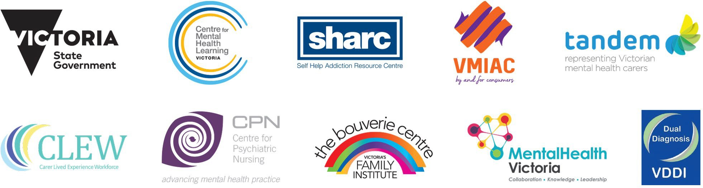

Contents

Introduction 3
Purpose 3
Stewardship of Victoria’s lived
experience workforce strategies 4
Strategy for the consumer mental
health workforce in Victoria 5
Vision for the consumer workforce 5
Principles and enablers 5
Model of success 5
Themes and objectives 6
Action Plan 7
APPENDIX 1
Victoria’s consumer workforce 12
APPENDIX 2
The Consumer Workforce Development group 13
APPENDIX 3
Organisations, resources and initiatives
that support the consumer workforce 13

Introduction

Consumer workforce positions referred to in this document are defined as paid positions within Victorian publically funded mental health services that require a lived experience of mental health issues as an essential part of the selection criteria, however the activity and supports detailed in this document could be applicable for any consumer perspective role (for example those in disability services or academic positions). There is more information outlining Victoria’s mental health consumer workforce in Appendix 1.
Since 2015, the Consumer Workforce Development Group have worked in partnership with the Department of Health and Human Services, Victoria (the department) to provide direction and advice for policy and initiatives that relate to the consumer workforce. Members of the Consumer Workforce Development Group are all consumer workers experienced across a range of roles, except for those who are department members. Members over the life of the group can be found in Appendix 2.
The Consumer Workforce Development Group and a similar Carer Workforce Development Group have had support from two state-wide workforce development positions since November 2016. These positions, located in the sector, have undertaken work together and separately with the respective consumer and family/carer workforce groups to advance the lived experience workforce in Victoria.
In collaboration with other consumer workers, the Consumer Workforce Development Group have developed a vision for the consumer workforce. Actions to make the vision a reality have been mapped out and are contained within this document. A significant amount of work towards the outlined vision is already underway, and there are a number of positions, organisations and initiatives in place to support the consumer workforce. A brief summary of these can be found in Appendix 3.

Purpose
The intention is for the Strategy for the consumer mental health workforce in Victoria (the Strategy) to support resourcing and planning for consumer workforce training and development over the coming years.
Initiatives from the Strategy will require consumer leadership in collaboration with other partners, with aspects of the Strategy requiring government investment and other organisational support to implement.
The Strategy will assist policy developers, funders, consumer workers and their employers, and will be useful for organisations planning to employ consumer workers. It describes the required activity needed to adequately support and develop the workforce and should be carried out in partnership and with leadership from consumer workers.

Stewardship of Victoria’s lived experience workforce strategies

Victoria’s lived experience workforce strategies comprise:
- Strategy for the consumer mental health workforce in Victoria
- Strategy for the family carer mental health workforce in Victoria
- Strategy for the alcohol and other drug (AOD) peer workforce in Victoria

Stewardship of these strategies is held collectively by (listed in alphabetical order):
- The Bouverie Centre, La Trobe University
https://www.bouverie.org.au/
- Carer Lived Experience Workforce Network (CLEW)
https://www.tandemcarers.org.au/carer-lived-experience-network.php
- Centre for Mental Health Learning (CMHL)
https://cmhl.org.au/
- Centre for Psychiatric Nursing, Melbourne University
https://healthsciences.unimelb.edu.au/
departments/nursing/about-us/centre-for-psychiatric-nursing
- Department of Health and Human Services
https://www2.health.vic.gov.au/mental-health
- Mental Health Victoria
https://www.mhvic.org.au/
- Self Help Addiction Resource Centre (SHARC)
http://www.sharc.org.au/
- Tandem http://www.tandemcarers.org.au/
- Victorian Dual Diagnosis Initiative Leadership Group (VDDI LG)
http://www.dualdiagnosis.org.au
- Victorian Mental Illness Awareness Council (VMIAC)
http://www.vmiac.org.au/

The Lived Experience Workforce Strategies Stewardship Group will:
- Advocate for, promote and support lived experience workforces.
- Identify and drive opportunities to progress toward the vision of the strategies.

- Identify, create or advocate for funding opportunities to undertake actions of the strategies.
- Provide leadership and oversight for implementation of, and progress towards, strategy priorities.
Many consumers and carers have experiences of seeking support from both mental health and alcohol and other drugs (AOD) services. Lived experience workers may have experienced both mental health and substance use issues, or supported a family member or friend who has experiences of both.
The strategies and stewardship group create a unique opportunity for a more inter-sectorial and collaborative approach to supporting
mental health and/or AOD consumers and their family/carers, regardless of which sector they interact with.
The strategies stewardship group includes representation from lived experience workforces, organisations and networks involved in research, mental health, AOD, and dual diagnosis. We come together in order to strengthen collaborative network alliances for the lived experience workforces and learn with and from each other.
We encourage organisations to adopt and support this action plan to expand and support the consumer workforce. Collective effort
is required to achieve the objectives in this Strategy and activity is already happening within services and beyond. To ensure that activity is recognised and can be shared and promoted across the consumer workforce, please advise of relevant activity by contacting:
Consumer Workforce Development Coordinator, CMHL Vic contact@cmhl.org.au

Strategy for the consumer mental health workforce in Victoria

Vision for the consumer workforce
In collaboration with members of Consumer Partnership Dialogue, the Consumer Workforce Development Group have developed a vision for the future of the mental health consumer workforce.

Principles and enablers
There are a number of principles and enablers that will support the achievement of the vision:
Principles: consumer-led and co-produced values are at the heart of everything we do.
Enablers: consumer ownership, consumer leadership, co-production, co-design, promotion of consumer work, collaboration with carer workforce, communication and dialogue with organisations including government.
Our vision for the future is a diverse consumer workforce that is clearly defined, recognised, authorised and has status as a separate, properly resourced discipline. It is driven and led by a critical mass of consumers and supported by organisations that are cognisant of the power imbalance.

Model of success
Figure 1 details what success looks like for a well-supported, thriving consumer workforce – the model proposes what would be seen if the right foundations were in place.

FIGURE 1: Model of success for a well-supported consumer workforce
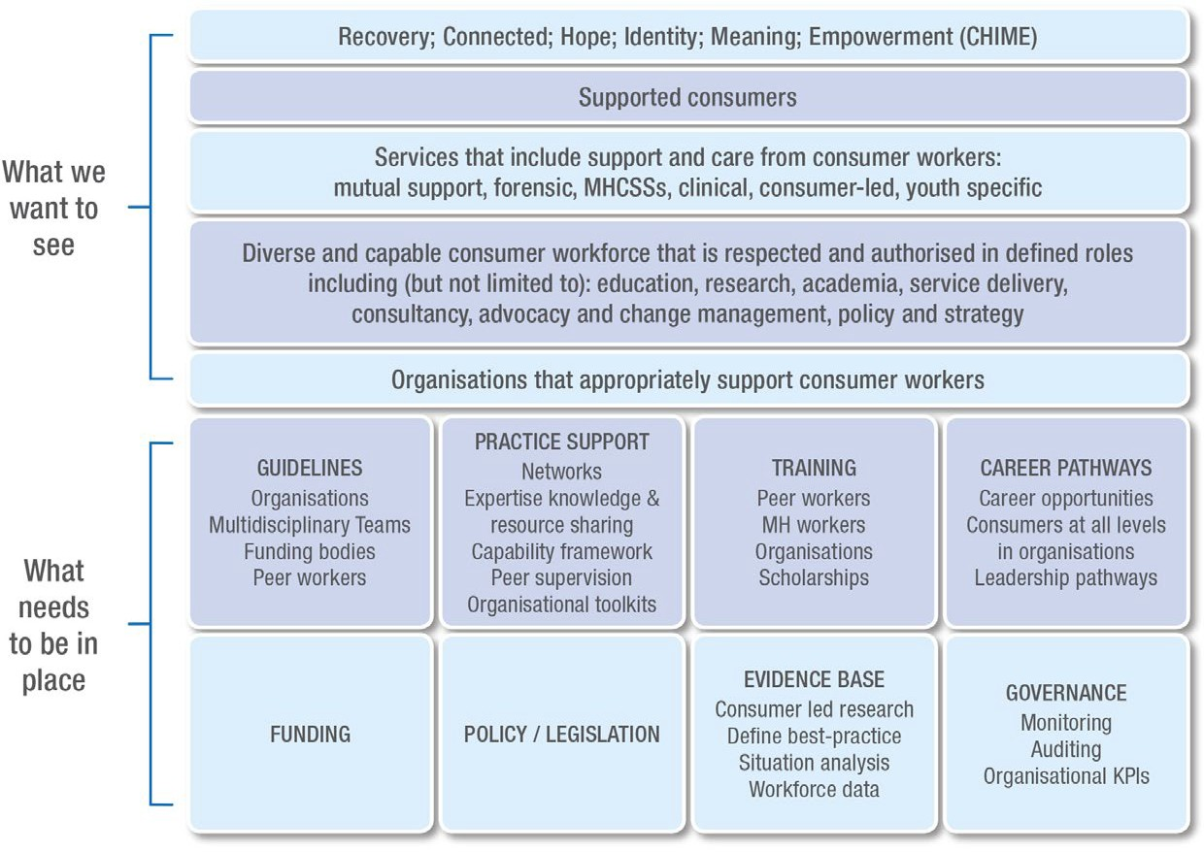

Themes and objectives
When considering the activity required to achieve the model of success for the consumer workforce as set out in Figure 1, four themes were identified:
  - Defining the discipline and roles;
  - Promoting consumer work;
  - Supporting the workforce, and
  - Growing the workforce

FIGURE 2: Consumer workforce strategy themes
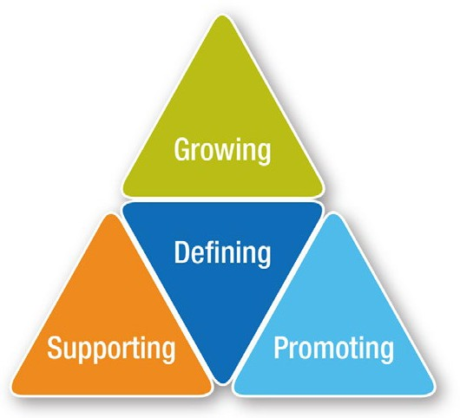

Figure 2 shows that defining the discipline is central as all other categories are dependent on a clear understanding of the work. Defining, together with promoting and supporting, make a strong foundation from which to grow the workforce.
Each of the themes has a number of objectives sitting within that theme, however in reality the objectives are interrelated and overlap.

Defining
  - Principles for consumer work are identified, developed and adopted.
  - Consumer work is clearly defined and articulated in position descriptions, policies and guidelines.

Promoting
- The evidence for consumer work is promoted.
- Organisations understand, support, and value consumer workers.

Supporting
- All consumer workers have access to consumer perspective supervision.
- Training needs for consumer workers and their employing organisations are identified and met with equity of access for all.
- Organisations know what conditions support best practice consumer work and create them.
- There is a resourced ‘home’ for consumer workforce (e.g. professional body). It
is consumer led, member-based, well resourced, strong and sustainable.

Growing
- There are clear career pathways for consumer workers, with diverse roles on offer - including in education, peer support, advocacy, leadership, research, policy, management, across sectors.
- There is an appropriate number of consumer workers within each organisation (including in DHHS, other government departments and all service settings and programs) to meet the demand.
- Consumer work has parity with other professions in services (pay, resourcing etc) and the same level of workplace support and advocacy.
- There are consumer workers in leadership roles that have genuine influence and resources.
Actions to achieve these objectives and the model of success for the consumer workforce were identified and prioritised in consultation with the workforce and health services. These are described in the following section.

1.1.2 Identify and clearly articulate specialities within discipline

Immediate

Action Plan

A guide to the proposed timeframes:
  - Immediate – complete within 12 months
  - Medium – complete within 3 years
  - Longer term – complete in 3 – 5 years

1DEFINING – the discipline and roles

OBJECTIVES

ACTIONS
PROPOSED TIMEFRAME

1.1 Principles for consumer work are identified, developed, adopted.

1.1.1 Principles underpinning consumer work are produced and widely circulated. These principles include core principles, and principles specific to education, training, research.

Immediate

Immediate

Medium

Immediate

1.2.2 Produce example Position Descriptions
that reflect best practice; create a set of core capabilities/requirements from which to draw.

1.2.3 Develop training relating to lived experience work, for example: What is unique about the roles; supporting workers to remain peer; mutuality; understanding power differentials; supervision training.
At beginner, intermediate and refresher levels
1.2.4 Collect example workforce models – develop case studies/examples for different models.

1.2 Consumer work is clearly defined in position descriptions, policies
and guidelines.

1.2.1 Support the development of policy documents, covering areas such as: role definitions; recruiting/employment of lived experience workers (including offering full time positions); enablers/barriers; supervision; reasonable adjustments; return to work; strategic plan for lived experience workforce.

Immediate

2.1.2 Consolidate the evidence for consumer-led services and provide to funding bodies and agencies.

2.1.3 Undertake and promote a systematic review of value and benefits of consumer perspective work.

Medium

Medium

Immediate

Medium

Immediate

Longer term

2.2.2 Produce and promote best practice guidelines for working with consumer workers.

2.2.3 Produce guidelines for organisations specifying the need for consumer workers to be able to attend consumer-led reflective practice opportunities within work time.

2.2.4 Promote the Growing Consumer Leadership domain of the Framework for recovery-oriented practice (2011) and develop appropriate audit tools.

2.2.5 Measure attitudes and culture of staff and organisational commitment to growing and supporting consumer workforce.
2PROMOTING THE WORK

OBJECTIVES

ACTIONS
PROPOSED TIMEFRAME

2.1 The evidence for consumer work is promoted.

2.1.1 Support and promote consumer led research through publication and dissemination.

Immediate

2.2 Organisations understand, support, and value consumer workers

2.2.1 Promote the expertise and value of the various consumer roles.

Immediate

3.1.2 Create access to consumer perspective supervision.
3.1.3 Identify, support and develop skills for the provision of consumer perspective supervision.

Immediate

Immediate

Immediate

Immediate

Medium

Medium

Immediate
3.2.2 Develop principles that underpin development and delivery of training for consumer workers.

3.2.3 Create a lived experience workforce training calendar available through the Centre for Mental Health Learning.
3.2.4 Develop training for all health service staff on the value of consumer work, the value of recovery, and how to work alongside consumer workers in your team.
3.2.5 Provide training, support and debriefing opportunities for consumer members of organisational boards and committees.
3.2.6 Provide resources for regional and rural workers to access training and networks.

3SUPPORTING THE WORKFORCE

OBJECTIVES
ACTIONS
PROPOSED TIMEFRAME

3.1 All consumer workers have access to consumer perspective supervision

3.1.1 Identify size and location of consumer workforce.

Immediate

3.2 Training needs for consumer workers and their employing organisations are identified and met with equity of access to all.
3.2.1 Identify training needs for consumer workers and their colleagues.

Immediate

3SUPPORTING THE WORKFORCE
(continued)

OBJECTIVES
ACTIONS
PROPOSED TIMEFRAME
3.3 Organisations know what conditions support best practice consumer work and create them.

3.3.1 Develop auditing and assessment tools to support organisations to understand what needs development and growth in relation to consumer work.

Medium

Medium

Medium

3.4.2 Collect historical and current knowledge from experienced consumer workers and make into accessible resources.
3.4.3 Produce entry standards for consumer work that don’t create barriers to becoming or being a consumer worker due to inappropriate or inaccessible selection criteria and qualification requirements.

3.4 There is a resourced ‘home’ for consumer workforce (e.g. professional body). It is consumer led, member-
based, well resourced, strong and sustainable.

3.4.1 Identify what/where a ‘body’ would be most appropriate.

Longer term
4.1.2 Identify and disseminate knowledge and skills required for the various consumer work roles.

4.1.3 Map and promote different career pathways for consumer workers. Identify training to support each pathway.
4.1.4 Create principles around education development and delivery processes are created to support consumer educator roles.

Medium

Medium

Immediate

Immediate

Immediate

4.3.2 Develop links with unions.
4.3.3 Increase union/professional body involvement in understanding and advocating for consumer workforce.

4GROWING THE WORKFORCE

OBJECTIVES
ACTIONS
PROPOSED TIMEFRAME

4.1 There are clear career pathways for consumer workers, with diverse roles on offer - including in education, peer support, advocacy, leadership, research, policy, management, across sectors.
4.1.1 Support organisations to co-design a strategy for developing consumer workforce roles including leadership positions.

Longer term

4.2 There is an appropriate number of consumer workers within each organisation (including in DHHS, other government departments and all service settings
and programs) to meet the demand.

4.2.1 Support organisations to identify and appropriately resource the optimum number and type of consumer roles to meet consumer needs and organisational activity.

Immediate

4.3 Consumer work has parity with other professions in services (pay, resourcing etc) and the same level
of workplace support and advocacy.
4.3.1 Advocate for changes to the current EBA that reflects growing expertise, experience and skills.

Immediate

4.4 There are consumer workers in leadership roles that
have genuine influence and resources.

4.4.1 Make leadership training and development available to consumer workers

Medium

APPENDIX 1
Victoria’s consumer workforce

A survey undertaken in 2017, identified 341 lived experience workforce positions in Victoria, totalling 187 EFT. More than two-thirds of Victoria’s lived experience workforce work from a consumer perspective (n = 238) as can be seen in Figure 3 below. Functions and responsibilities of each title identified may vary service to service. All educator/trainer positions (n = 16) are employed on a casual basis, apart from 3 positions. ‘Other’ positions identified were described as advisory roles, group facilitation, and NDIS transition roles.

FIGURE 3: Consumer Lived Experience Workforce, Victoria

250
238

200
159
38
6
16
15
4

150

100

50

0

Hours of employment - full time equivalent (FTE):
- 42 of the consumer positions are employed at 2 days or less per week.
- 42 positions are employed at 3 days per week.
- 67 positons are employed at 4-5 days a week.
- 18 positions are casual or sessional.

Leadership positions
One of the challenges for the consumer workforce is the limited career development pathways into leadership positions within mental health services. The survey demonstrated that for the 238 consumer positions, there were eight positions that managed other consumer workers as part of their role, and 17 that were providing discipline specific supervision to consumer workers.

APPENDIX 2
The Consumer Workforce Development group

The vision and strategy would not be possible without input from the following people:

  - Wanda Bennetts
  - Emma Cadogan
  - Deb Carlon
  - Rick Corney
  - Michelle D’Sant Anna
• Indigo Daya
  - Vrinda Edan
  - Erandathie Jayakoby
  - Mark Lacey
  - Tania Lewis
• Ali Pain
  - Ben Rinaudo
  - Krystyn Smale
  - Neil Turton-Lane

APPENDIX 3
Organisations, resources and initiatives that support the consumer workforce Vision for the consumer workforce

This section outlines existing structures (such as organisations and networks), resources and initiatives that will support achievement of the actions in this strategy. It is recognised that these structures and initiatives are growing and evolving, and the current content reflects the situation as at January 2019.

Organisations
Centre for Mental Health Learning (CMHL) – a central hub for mental health workforce in Victoria and have lived experience leadership embedded through consumer and carer workforce development positions. They provide resources, support and advice for lived experience workers and their employing organisations. Further information is at
http://www.cmhl.org.au/peer-inside
Department of Health and Human Services (DHHS) – support mental health workforce and consumer and carer workforce through specific initiatives. See for further information:
https://www2.health.vic.gov.au/mental-health/workforce-and-training/lived-experience-workforce
Intentional Peer Support (IPS) – a peer-led organisation that provide training on the Intentional Peer Support model. SHARC auspice the IPS Australia Hub – more information can be found at
http://www.intentionalpeersupport.org/what-is-ips/
National Mental Health Commission – support mental health peer work development and promotion. Tools and resources related to peer work and further information can be found at: www.mentalhealthcommission.gov.au/our-work/mental-health-peer-work-development-and-promotion.aspx

Self Help and Addiction Resource Centre (SHARC) – lead peer workforce development in the AOD sector, and support a number of peer projects including an AOD peer worker community of practice. They also promote collaboration between lived experience workers across mental health and AOD. Further information can be found at:
http://www.sharc.org.au/peer-support/
The Centre for Psychiatric Nursing (CPN) Melbourne University – support a consumer academic program, comprising several part-time positions and a senior state-wide consumer academic position currently held by Cath Roper. She can be contacted via email croper@unimelb.edu.au or via telephone (03) 8344 9455
Unions – The Health and Community Services Union (HACSU) and the Australian Services Union (ASU) are the unions that represent members that work in mental health services. HACSU are for workers in clinical services, more information can be found at: https://hacsu.asn.au/
and ASU is for workers employed in community services, more information can be found at: https://www.asu.asn.au/
Victorian Mental Illness Awareness Council) – is the peak Victorian non-government organisation for people with lived experience of mental health or emotional issues. VMIAC engages in a number of activities, including information provision, peer support and self-help.
VMIAC provides individual, group and systemic advocacy along with research and evaluation, education and training. VMIAC’s vision is a world where all mental health consumers stand proud, live a life with choices honoured, rights upheld and these principles embedded in all aspects of society. Further information can be found at
https://www.vmiac.org.au/

Networks
Online communities of practice are hosted on Basecamp and managed by CMHL. To arrange access to these groups contact the Consumer Workforce Development Co-ordinator at contact@ cmhl.org.au Groups include:
- Consultants
- Peer support workers
- Consumer perspective supervisors

State-wide positions
- Consumer Workforce Development Coordinator at CMHL: contact@cmhl.org.au
- Consumer Academic (Melbourne University) Cath Roper: croper@unimelb.edu.au

Information and resources
  - Lived experience workforce positions in Victorian public mental health services – information about lived workforce positions in Victoria as at October 2017. The report can be accessed from:
https://www2.health.vic.gov.au/mental-health/workforce-and-training/lived-experience-workforce
  - Co-production - putting principles into practice in mental health contexts – a resource that provides information about principles of co-production and experiences of putting these into practice. The resource can be accessed from:
https://recoverylibrary.unimelb.edu.au/__data/assets/pdf_file/0010/2659969/Coproduction_putting-principles-into-practice.pdf
  - Consumer perspective supervision framework
https://cmhl.org.au/sites/default/files/resources-pdfs/FINAL CPS framework 18.pdf
  - Victorian lived experience workforce – training needs analysis

Preparing your organisation for the expanding post-discharge support initiative. This resource can be accessed from: https://www2.health.vic.gov.au/~/media/health/files/collections/policies%20and%20guidelines/e/expanding%20post-discharge%20support%20resource.pdf
  - CMHL have a range of resources including videos about peer support and experiences of being a consumer worker, links to relevant guidelines and legislation; and tip sheets.
  - Centre for Excellence in Peer Support:
https://www.peersupportvic.org/
  - The National Mental Health Consumer and Carer Forum (NMHCCF) – a combined national voice for mental health consumers and carers; “We listen, learn, influence and advocate in matters of mental health reform.” Victoria’s current NMHCCF representative is Keir Saltmarsh, and the NMHCCF produce advocacy briefs, position statements and submissions. Updates on activities, meeting reports and publications can be found at:
https://nmhccf.org.au/

Work underway 2018 – 2019
- Expanding Post Discharge Support initiative research project – looking at peer support in clinical mental health services in Victoria

Consumer Perspective Supervision project:
- Guide to consumer perspective supervision for organisations
- Development of a supervisor database for supervisees to access consumer perspective supervision
- Developing accessible training and supports for supervisors
- Consumer-led workforce innovation grant projects, described below:

CONSUMER-LED WORKFORCE INNOVATION GRANT PROJECTS

PROJECT LEAD

ORGANISATION

PROJECT TITLE

Graham Panther

The Big Feels Club

Big Feels at Work (BFW): support resources for mental health workers with lived experience

Leah McKenner
Orygen Youth Health / NorthWestern Mental Health

Understanding and responding to suicidality - training for the lived experience workforce

Donna Matthews

NorthWestern Mental Health

Lived experience work education/training video for clinical staff

Shifra Armitage

Centre for Mental Health, University of Melbourne

Navigating dual consumer / researcher Identities: Auto- ethnographic approach (research)

Angela Nolan

Forensicare

Mental Health Lived Experience Workforce within the Justice System (research)

